The Jelly Blubbers Colony Name___________________
Read this page before completing the task! Period_____Date__________

Today we are going to investigate more closely how sampling method and sampling size affect an estimate by sampling from a population of 100 Jelly Blubbers in order to find the average length of a jelly blubber from this colony.

1. Take a quick look at the Jelly Blubber Colony handout (on back). Estimate the average length of a jelly blubber, by selecting 2 jelly blubbers that, in your judgment, are representative of the entire colony. Record the numbers corresponding to those jelly blubbers in the chart below.

2. Now, select 10 jelly blubbers that, in your judgment, are representative of the entire colony. Record the numbers corresponding to those jelly blubbers below also.

3. Now refer to the table of jelly blubber lengths (on page 3) and compute the average length of your 2 jelly blubber samples.

2  JB | Number |  |  | Ave.
 | Length
10  JB | Number |  |  |  |  |  |  |  |  |  |  | Ave.
 | Length

This is a Convenience Sample and is NOT a Random Sampling Method and can introduce bias into a survey. Now, let’s look at some non-bias Random Sampling Methods.

4. Perform a Simple Random Sample: On the home screen of your calculator, type in your phone number, then cvbnm,./~!@#$%^&*(()_+QWERTYUIOP{}|”:LKJHGFDSAZXCVBNM<>? and then use it to generate 2 random numbers from 1 to 100. (The command is RandInt(1, 100).) These 2 numbers represent the jelly blubbers chosen for your sample. Record the results in the table below. Once again, refer to the table and calculate the average length for these 2 jelly blubbers. (Jelly blubbers may NOT be repeated.)

5. Now use a calculator to generate 10 random numbers from 1 to 100. These 10 numbers represent the jelly blubbers chosen for your sample. Record the results in the table below. Using the table of jelly blubber lengths, calculate the average length for these 10 jelly blubbers. (Jelly blubbers may NOT be repeated.)

2  JB | Number |  |  | Ave.
 | Length
10  JB | Number |  |  |  |  |  |  |  |  |  |  | Ave.
 | Length

6. Compare and contrast these results.

7. Go to https://goo.gl/forms/wgnuQpmbKh43YZ6W2 and fill in your results.

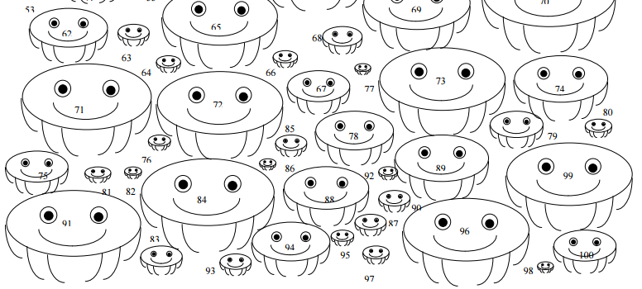
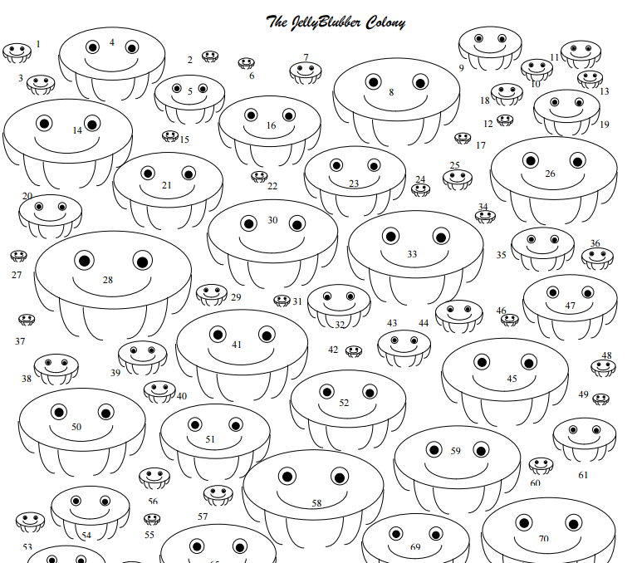

The Jellyblubber colony: data
Blubber # | Length |  | Blubber # | Length |  | Blubber # | Length
1 | 9 |  | 35 | 20 |  | 68 | 13
2 | 5 |  | 36 | 10 |  | 69 | 34
3 | 9 |  | 37 | 5 |  | 70 | 42
4 | 33 |  | 38 | 14 |  | 71 | 40
5 | 22 |  | 39 | 15 |  | 72 | 40
6 | 5 |  | 40 | 10 |  | 73 | 40
7 | 10 |  | 41 | 41 |  | 74 | 30
8 | 40 |  | 42 | 5 |  | 75 | 20
9 | 20 |  | 43 | 17 |  | 76 | 7
10 | 10 |  | 44 | 15 |  | 77 | 5
11 | 12 |  | 45 | 40 |  | 78 | 25
12 | 5 |  | 46 | 5 |  | 79 | 17
13 | 8 |  | 47 | 30 |  | 80 | 8
14 | 41 |  | 48 | 8 |  | 81 | 8
15 | 5 |  | 49 | 5 |  | 82 | 5
16 | 32 |  | 50 | 40 |  | 83 | 13
17 | 5 |  | 51 | 35 |  | 84 | 42
18 | 10 |  | 52 | 37 |  | 85 | 10
19 | 21 |  | 53 | 9 |  | 86 | 5
20 | 20 |  | 54 | 25 |  | 87 | 10
21 | 34 |  | 55 | 5 |  | 88 | 27
22 | 5 |  | 56 | 10 |  | 89 | 30
23 | 32 |  | 57 | 9 |  | 90 | 10
24 | 5 |  | 58 | 45 |  | 91 | 42
25 | 9 |  | 59 | 40 |  | 92 | 6
26 | 40 |  | 60 | 8 |  | 93 | 10
27 | 5 |  | 61 | 20 |  | 94 | 25
28 | 49 |  | 62 | 25 |  | 95 | 7
29 | 9 |  | 63 | 10 |  | 96 | 40
30 | 41 |  | 64 | 8 |  | 97 | 8
31 | 5 |  | 65 | 37 |  | 98 | 5
32 | 20 |  | 66 | 8 |  | 99 | 40
33 | 43 |  | 67 | 20 |  | 100 | 20
34 | 7

Data from a previous year yielded these histograms.

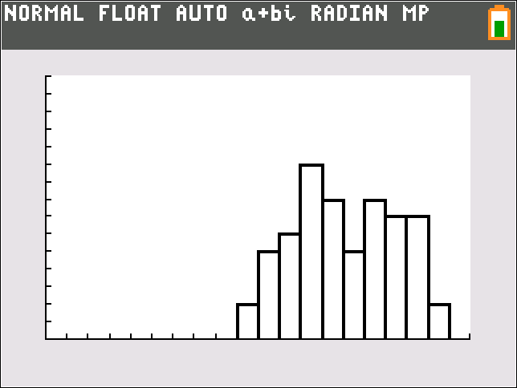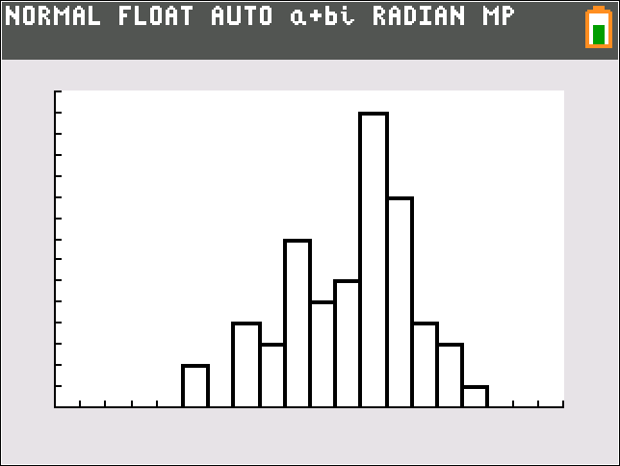

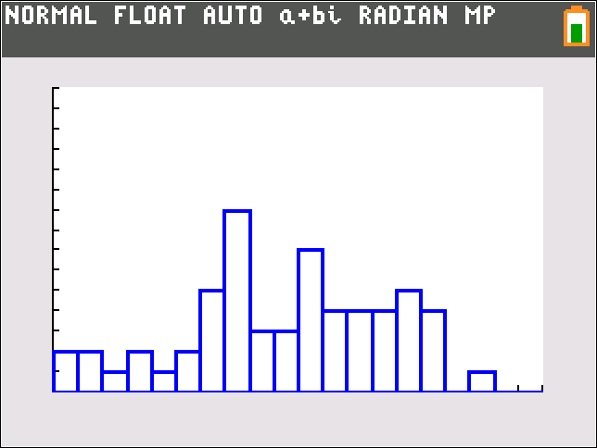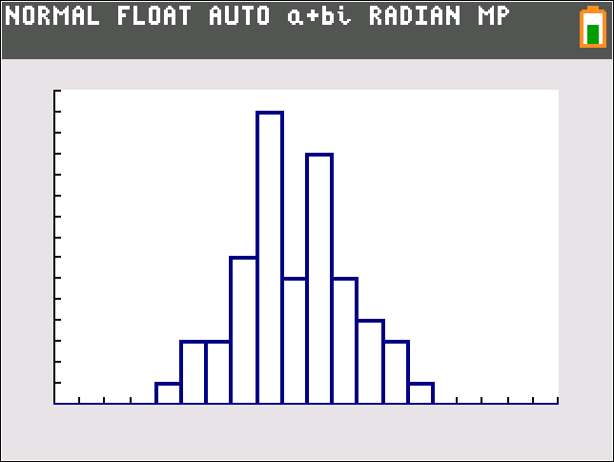

On Monday, I will post the actual distribution of J Bs. With the mean and standard deviation.

What method of sample selection do you feel is best and why?

What are the 3 aspects of the Central Limit Theorem:

1.

2.

3.

How did those show up in this task?

Design a survey to gather data on JBs using stratified sampling.

Design a survey to gather data on JBs using the cluster sampling method.

Design a survey to gather data on JBs using a systematic sample.

