Testing Task Name_______________________

Today you are going to determine how well you would do on a true/false test if you guessed at every answer. Take out a sheet of paper. Type randint(1,2) on your calculator. If you get a 1, write “true.” If you get a 2, write “false.”
Do this 20 times.
Before the teacher calls out the answers, how many do you expect to get correct? Why?
Grade your test.* (We’ll do this in class.) How many did you actually get correct? Did you do better or worse than you expected?
1) Make a dot plot of the class distribution* of the total number correct on graph paper.
2) Calculate the mean and median of your distribution. Which measure of center should be used based on the shape of your dot plot?
3) Based on the class distribution, what percentage of students passed?

4) Calculate the probabilities based on the dot plot:
a) What is the probability that a student got exactly 10 correct?
b) What is the probability that a student got between 9 and 11 correct (inclusive)?
c) What is the probability that a student got 15 or more correct?
d) What is the probability that a student passed the test?
e) Is it more likely to pass or fail a true/false test if you are randomly guessing?
For a situation to be considered as having a binomial distribution, the following conditions must be satisfied:
• Each observation/trial has one of two outcomes. These two outcomes are referred to as “success” or “failure”.
• There are a fixed number of observations/trials. The number of observations/trials is referred to as n.
• The observations/trials must be independent.
• The probability of success, referred to as p, is the same for each observation/trial.

5) Can this true-false test be considered a binomial setting? Why or why not?
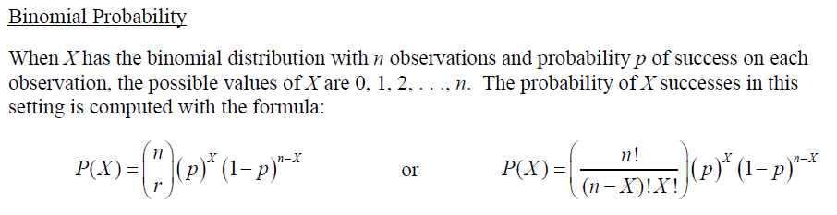
6) Still considering that T-F test, calculate the following probabilities using the Binomial Distribution:
a) What is the probability that a student got exactly 10 correct?
b) What is the probability that a student got between 9 and 11 correct (inclusive)?
c) What is the probability that a student got 15 or more correct?
d) What is the probability that a student passed the test?
e) Is it more likely to pass or fail a true/false test if you are randomly guessing?
Testing Learning Task (Part 2)
Suppose there is a 5 question multiple choice test. Each question has 4 choices (A, B, C, or D).
1) Can this multiple choice test be considered a binomial setting? Why or why not? 2) If you are strictly guessing, calculate the following probabilities:
a) P(0 correct) =
b) P(1 correct) =
c) P(2 correct) =
d) P(3 correct) =
e) P(4 correct) =
f) P(5 correct) =
3) Draw a histogram of the probability distribution for the number of correct answers on graph paper. Label the x-axis as the number of correct answers. The y-axis should be the probability of x.
4) Based on the distribution, how many problems do you expect to get correct?
5) Based on the distribution, how likely is it that you would pass if you were strictly guessing? (Calculate the probability of getting 4 or 5 correct.)
6) What is the probability that you will get less than 3 correct?
7) What is the probability that you will get at least 3 correct?
Testing Learning Task (Part 3)
Earlier, we found the probability that the student passed a multiple choice test just by random guessing. However, we know that students usually have a little more knowledge than that, even when they do not study, and consequently do not guess for all problems. Suppose that a student can retain about 30% of the information from class without doing any type of homework or studying. If the student is given a 15 question multiple choice test where each question has 4 answer choices (A, B, C, or D), then answer the following questions:
1. What is the probability that the student gives the correct answer on the test? What would be her percentage score on a 15 question test?

2. Given she provides the correct answer on the test, what is the probability that she strictly guessed?
