Spheres and Other Surfaces Name__________________________________

Period________Date____________________

In 2D, the equation of a circle comes directly from the Pythagorean Theorem - i.e.

(x – h)2 + (y – k)2 = r2. Well, just as the distance formula in 3D merely includes one more dimension than 2D, the equation of a sphere is just an extension of the equation of a circle: -

(x – x1)2 + (y – y1 )2 + (z – z1)2 = r2 , where (x1, y1, z1) is the center and r is the radius of the sphere. (Sometimes completing a square is required.)

Try These:

1. What is the center and radius of the sphere: x2 + (y – 6)2 + (z + 12)2 = 36?

2. What is the center and radius of: x2 + y2 + z2 + 6x – 8y = 12? Does this sphere intercept any of the three coordinate axes? If so, which ones?

3. Write the equation of a sphere with center at (3, -1, 0) with radius 22.

4. Write the equation of the sphere with diameter whose endpoints (2, -4, 1) and (4, 4, -3).

5. What is the center and radius of the circular trace that x2 + y2 + z2 + 2x – 8y + 12z = 24 makes with the XY plane.

6. What is the center and radius of the circular trace that x2 + y2 + z2 + 2x – 8y + 12z = 24 makes with the XZ plane.

7. What is the surface area of the sphere in problem #1?

8. What is the volume of the sphere in problem #2?

9. Where does the line given by r = <1, 2, 4> + d<3, -2, 4> intersect the sphere:

(x – 2)2 + (y – 2)2 + (z – 5)2 = 64?

10. What is the center and radius of the circular trace that x2 + y2 + z2 + 2x – 8y + 12z = 24 makes with the YZ plane.

11. What are the traces of the graph of 2x2 + 6y2 + 3z2 = 24? What is its shape? Sketch it.

12. 2x2 + 6y2 + 3z = 24 is a paraboloid. What are its traces? Sketch its graph.

Try These:

1. What is the center and radius of the sphere: x2 + (y – 6)2 + (z + 12)2 = 36?

*C:(0, 6, -12), r = 6. This sphere is cut into hemispheres by the ZY plane, tangent to the XZ*

*plane and doesn’t intersect the XY plane.*

2. What is the center and radius of: x2 + y2 + z2 + 6x – 8y = 12? Does this sphere intercept any

of the three coordinate axes? If so, which ones? (x + 3)2 + (y – 4)2 + z2 = 12 + 9 + 16 = 37

*C:(-3, 4, 0), r =  . If x = 0 and y = 0, z2 =37 – 9 – 16 = 12, so the sphere will*

*intersect the z axis at z = . If x = 0 and z = 0, (y – 4)2 = 37 – 9 = 29, so the*

*sphere will intersect the y axis at . If y and z = 0, (x + 3)2 = 37-16 = 21, so the*

*sphere will intersect the x axis at *

3. Write the equation of a sphere with center at (3, -1, 0) with radius 22.

*(x – 3)2 + (y + 1)2 + z2 = 484.*

4. Write the equation of the sphere with diameter whose endpoints (2, -4, 1) and (4, 4, -3).

*(x – 3)2 + y2 + (z + 1)2 = 441*

5. What is the center and radius of the circular trace that x2 + y2 + z2 + 2x – 8y + 12z = 24

makes with the XY plane.

*Let z = 0 and we get (x2 + 2x + y2 - 8y = 24 ⇒ (x + 1)2 + (y – 4)2 = 41,*

*so the center is (-1, 4, 0) and the radius =  .*

6. What is the center and radius of the circular trace that x2 + y2 + z2 + 2x – 8y + 12z = 24

makes with the XZ plane.

*Let y = 0 and we get (x2 + 2x + z2 + 12z = 24 ⇒ (x + 1)2 + (z + 6)2 = 61,*

*so the center is (-1, 0, -6) and the radius =  .*

7. What is the surface area of the sphere in problem #1? *SA =* **

8. What is the volume of the sphere in problem #2 **

9. Where does the line given by r = <1, 2, 4> + d<3, -2, 4> intersect the sphere:

(x – 2)2 + (y – 2)2 + (z – 5)2 = 64*? Parametric equations of the line are: x = 1 + 3t, y = 2 – 2t*

*and z = 4 + 4t. Substituting into the sphere, we get: (1 + 3t- 2)2 + (2 – 2t – 2)2 + (4 + 4t – 5)2*

*= (3t – 1)2 + (-2t)2 + (4t – 1)2 = 64 ⇒ 9t2 – 6t + 1 + 4t2 + 16t2 – 8t + 1 = 64 → 29t2 -14t – 62 = 0 →*

*t ≈ 1.723 → Point is (6.17, -1.447, 10.89) and t ≈-1.241 → point is (-2.722, 4.481, -.9623)*

10. What is the center and radius of the circular trace that x2 + y2 + z2 + 2x – 8y + 12z = 24

makes with the YZ plane. *Let x = 0 and we get y2 – 8y + z2 + 12z = 24 ⇒ (y - 4)2 + (z + 6)2 =*

*24 + 16 + 36 = 76, so the center is (0, 4, -6) and the radius =  .*

11. What are the traces of the graph of 2x2 + 6y2 + 3z2 = 24? What is its shape? Sketch it.

*x2 + 3y2 = 12, 2y2 + z2 = 8, 2x2 + 3z2 = 24. It is an ellipsoid.*

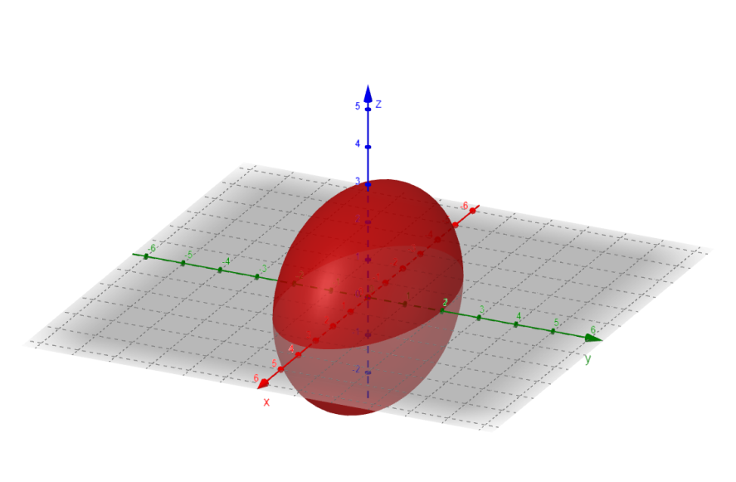

12. 2x2 + 6y2 + 3z = 24 is a paraboloid. What are its traces? Sketch its graph.

x2 + 3y2 = 12, 2x2 + 3z = 24, 2y2 + z = 8

