Prob/Stat Quiz Name_______________________

Period______Date_____________

I. Write the letter corresponding to the most correct answer in the space provided.

______1. There are six different pencils in my desk drawer. In how many different ways

can I choose 2 of them to put in a pencil pouch to carry home?

A) 36 B) 30 C) 15 D) 12 E) 11

______2. Four coins are tossed. What is the probability that at least 2 land “heads up”?

A)  B)  C)  D)  E) 

______3. What is an expression for P(n, 3)?

A) n3 – 3n2 + 2n B) n2 – 3n + 2 C) 3n - 3

D) n3 – 3n2 + 3n – 1 E) n2 – 2n + 1 F) 3n + 3

______4. An amusement park has a ride in which 6 people get into a

boat and ride through a river with rapids. In how many

different ways can my “family” of 6 ride in such a boat if

Stewart wants to sit beside me? (This boat is symmetric.)

A) 720 B) 120 C) 60 D) 48 E) 36

______5. In order to get a sample of Georgia voters, a political candidate randomly

selects 1 person from each county in Georgia. What type of sample is this?

A) Cluster Sample B) Simple Random Sample

C) Stratified Sample D) Systematic Sample

E) Geographic Sample

______6. What is the sample standard deviation of { x-2, x-1, x, x, x+1, x+2 }?

A)  B)  C)  D) 1 E) none of these

______7. According to Animalplanet.com, the mean weight of a German shepherd is 85

pounds with a standard deviation of 5 pounds. If this is a normal distribution,

what percent of German shepherds should weigh above 90 pounds?

A) 68% B) 45% C) 34% D) 16% E) 5%

______8. Using the information from #5, what is the z-score for a weight of 78 pounds?

A) -7 B) -1.4 C) -0.7 D) 0.7 E) 1.4

_____9. In order to determine what proportion of high school students got 8 or more

hours of sleep per night, a sample of 400 randomly selected high school

students was asked if they slept 8 or more hours a night and 144 said that they

did. What is the value of  for this survey?

A) 14.4% B) 18% C) 36% D) 50% E) 64%

______10. If the z*score for the desired confidence interval is 2, use the information

from problem #9 to find the margin of error for the confidence interval for the

proportion of high school students who get 8 hours of sleep or more.

A) .48 B) .096 C) .05 D) .048 E) .024

______11. Which of the following statements are true about the data from a normal curve?

i) Approximately 68% of data lies within 1 standard deviation of the mean.

ii) Approximately 34% of the data lies within ½ standard deviation of the mean.

iii) Almost all of the data lies within 3 standard deviations of the mean.

A) only i B) only iii C) only i and ii D) only i and iii E) i, ii and iii

II. Show work to completely answer each of the following:

12. Describe how you would find the answer to this question if given a calculator. According to Animalplanet.com, the mean weight of a German shepherd is 85 pounds with a standard deviation of 5 pounds. If this is a normal distribution, what percent of German shepherds should weigh below 78 pounds?

According to the last US Census, about 1 out of 4 Georgians have a bachelor’s degree or higher.

13. If I randomly select 4 Georgians at random, what is the probability that exactly one person has a bachelor’s degree or higher?

14. If I randomly select 4 Georgians at random, what is the probability that less than 2 people have a bachelor’s degree or higher?

I have 4 different white shirts and 2 different blue shirts that I’m thinking of carrying on vacation.

15. If I randomly grab three shirts at random, what is the probability that exactly 2 will be white?

16. If I randomly grab three of these shirts, what is the probability that at least 2 are white?

A survey of 400 Lassiter students were asked if they

|  |  |  |  |
| --- | --- | --- | --- |
|  | Travelled Outside US | Never Travelled Outside US | Totals |
| Male | 70 | 155 | 225 |
| Female | 80 | 95 | 175 |
| Totals | 150 | 250 | 400 |

had ever traveled outside the US and the results

are in this table.

17. What is the probability that if I randomly

choose one of these students, it will be a male

who has travelled outside the US?

18. What is the probability that if I randomly choose a male, that he has travelled outside the US?

19. If I find, through discussion, that one of these students has been to Scotland, what is the probability that the student is female?

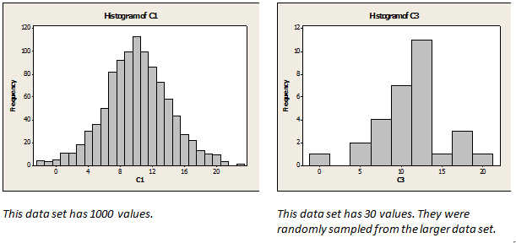Using this histogram,

approximate the mean and the standard deviation of this data.

20.  = ____________

21.  = ___________

In order to design a new wristband for an exercise tracker, a company hired students from 100 colleges across the USA to take a random sample of 25 adults and find the mean circumference of their wrists. The mean of all these samples is 10 inches and the standard deviation of these sample means is 1 inch.

22. If the z* score for the 95% confidence interval is 2, show work find a 95% confidence interval for the mean wrist circumference for all adults in the USA.

.

If the conditions for the Central Limit Theorem are met, what 3 conclusions can be drawn from this study? Be as precise as possible.

23.

24.

25.